Polymerase Chain Reaction (PCR) Based Identification of Meticillin Resistant Staphylococcus Aureus (MRSA)
College of Engineering, Environment, and Sciences, Coventry University
5007BIO: Microorganisms in Human Health and Disease
Dr Jamie Beddow and Gaetano Del Gaudio
3 December, 2025

Introduction
Staphylococcus aureus is a gram-positive organism that can be found on skin and mucosal surfaces, normally not causing infection on healthy skin. (Taylor and Unakal, 2023) S. aureus adapts promptly to selective pressures from human hosts such as immune response or drug doses by increasing the frequency of beneficial mutations and decreasing harmful ones, leading to the emergence of new strains. (Malachowa and DeLeo, 2010) S. aureus can transfer mobile genetic elements (MGE), which is a process also known as lateral or horizontal gene transfer (HGT). MGEs consist of insertion sequences, phages, and plasmids, which can all be integrated into the DNA of a new host.

Figure 1
Horizontal and Vertical Gene Transfer

(From Malachowa and DeLeo, 2010)

Naturally occurring S. aureus that is resistant to antibiotics by mutation of a penicillin-binding protein can transfer its MGE to other bacteria through HGT using bacteriophages (fig. 1) (Siddiqui and Koriala, 2023), resulting in the emergence of antibiotic-resistant strains. The key material for this resistance is the mecA gene sequence, which generates transpeptidase PB2a (Penicillin-binding protein 2a) that lowers the affinity of S. aureus and beta-lactam antibiotics (Shahkarami et al., 2014) by catalysing cell-wall crosslinking even in the presence of antibiotics. (Fishovitz et al., 2014) These S. aurei that are resistant to beta-lactam antibiotics such as Methicillin, oxacillin, and nafcillin are grouped as MRSA (Meticillin Resistant Staphylococcus Aureus). Other strains that can be treated with those drugs are classified as MSSA. (Methicillin Susceptible Staphylococcus Aureus) (Rao et al., 2010) Taking antibiotics (selective pressure) then enriches MRSA in the host, eliminating only MSSA. (Fig. 1.)

Table 1
Prevalence of healthcare-associated MRSA (HA-MRSA) and community-acquired MRSA (CA-MRSA) in Different Countries
Year of study | Prevalence | Sample size | Sample sources | Country | References
Hospital-acquired MRSA (HA-MRSA)
2016 | 4.6% | 726 | Health care workers | Germany | Sassmannshausen et al., 2016
2017 | 52% | 180 | Human blood | Pakistan | Siddiqui et al., 2017
2021 | 19.1% | 47 | Nose, pharynx, and mobile phone | Mexico | Hamdan-Partida et al., 2022
Community-acquired MRSA (CA-MRSA)
2009 | 38.5% | 120 | Dialysis patients | United Kingdom | Johnson et al., 2009
2020 | 84.9% | 456 | Blood | Australia | Coombs et al., 2022
(From Shoaib et al., 2023)
Note. This table was chronologically reordered and summarised from the original data. The full dataset is available in Appendix and the original publication: https://pmc.ncbi.nlm.nih.gov/articles/PMC9871788/

Table 1 represents the prevalence of MRSA in different environments and samples in various countries. Differences in prevalence rely on other factors rather than time: country, sample sources, and settings (HA-MRSA/ CA-MRSA). As the prevalence in Pakistan (2017, 52%), Australia (2020, 84.9%) shows, sample collected from human blood presents a much higher prevalence of MRSA in both HA-MRSA and CA-MRSA, indicating bacteraemia occurred. On the other hand, in the case of Mexico (2021, 19.1%) and Germany (2016, 4.6%), prevalences are relatively lower in screening experiments. (nasal, pharynx/ healthcare workers) It should also be considered that in the UK (2009, 38.5%), the prevalence was measured within dialysis patients who have weaker immune systems and higher chances of infections due to frequent use of dialysis catheters. Therefore, it can be concluded that the sample source and study population make a considerable contribution to prevalence differences than geographic location in the epidemiology of MRSA and making it highly heterogeneous.
Moreover, following statistics in the UK also confirms that MRSA epidemiology remains unstable: the data collected since 2007/08 represents significant decrease in the number of cases of MRSA over a 15-year period, (UKHSA, 2023) but the infection rate of October to December 2024 has risen to 2.0 per 100,000 population, marking an increase of 11.7% compared to the same quarter the previous year. (UKHSA, 2024) This highlights the need for rapid and accurate diagnosis of MRSA through methods like PCR (Polymerase Chain Reaction) and LAMP (Loop-mediated isothermal amplification) targeting the mecA gene in MRSA. In this experiment, PCR was used to determine the presence of the gene because of its high sensitivity compared to LAMP due to cycling temperatures and rapid processing. Furthermore, the PCR product is subsequently validated using gel electrophoresis, which separates DNA fragments by size via electric current.
The experiment aims to utilise PCR to differentiate MRSA and MSSA genetically via extracting high-quality DNA from control (MRSA, MSSA) and clinical isolates, confirming the PCR amplification using gel electrophoresis.

Materials and Methods
The experiment was conducted under the protocol given by Coventry University (2025).

Results
Figure 2 shows the nanodrop spectrum of each extracted DNA, all three characterised by a steeply decreasing slope. What is remarkable about these graphs is the peak at 230nm rather than 260nm, which indicates the presence of contaminants such as chaotropic salts, phenol, or ethanol. (Koetsier and Cantor, 2019)

Figure 2
Nanodrop Spectrum of Sample 6 (Clinical Isolate), MRSA, MSSA
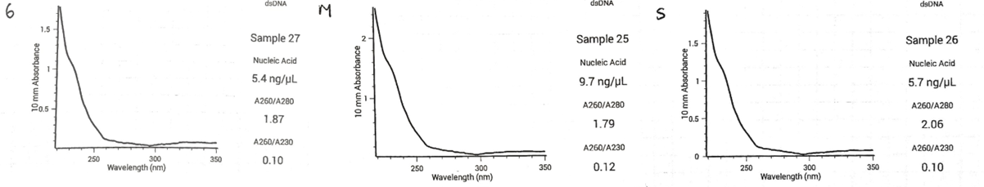
Note. 6, M and S (left top corner) refer to Clinical isolate, MRSA, and MSSA, respectively. The X-axis represents wavelength (nm), and the Y-axis shows absorbance measured over a 10nm optical path length.

Table 2
DNA Concentration and Purity Ratios of Controls and the Clinical Sample
Extract | DNA concentration | Ratio
 | ng/μl | 260/280nm | 260/230nm
Control MSSA strain | 5.7 | 2.06 | 0.10
Control MRSA strain | 9.7 | 1.79 | 0.12
Clinical sample | 5.4 | 1.87 | 0.10

As summarised in Table 2, DNA concentration varies from 5.7-9.7 ng/μl. 260/280nm ratios were around 1.79-2.06, whilst 260/230nm ratios were significantly lower at 0.10-0.12.

Figure 3
Gel Electrophoresis from the PCR Products
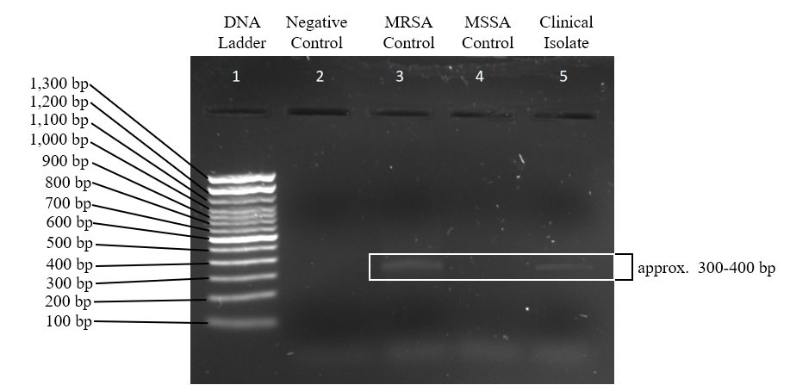
(From Coventry University, 2025)
Note. The data was provided by Coventry University as a successful outcome: sample data was used in this lab report due to unreadable original data, which is included in the Appendix.

Figure 3 illustrates the sample data of gel electrophoresis from the PCR products read under UV light. DNA ladder, negative control (water), MRSA control, MSSA control, and clinical isolate were loaded to Lane 1-5, respectively. Lane 3 (MRSA Control) and Lane 5 (Clinical Isolate) showed a clear band around 300 bp, and Lane 4 (MSSA Control) did not show any bands.

Discussion
The original aim of the experiment was to define the clinical isolate by checking the presence of the mecA gene via DNA extraction, PCR, and gel electrophoresis. The unexpected nanodrop spectra peak at 230nm from all three DNA extractions led to a significantly lower 260/230 ratio (0.10-0.102) than the ideal, which is 2.3-2.4. (Koetsier and Cantor, 2019) A possible reason for this is insufficient removal of buffer AW1 and AW2, which contain guanidine hydrochloride and ethanol. (QIAGEN, 2021) Figure 4 represents two nanodrop curves from DNA extraction, initial DNA and desalinated DNA. It is clear that the desalination led to lower absorbance at 230nm, which supports the hypothesis that the unusual peak at 230nm was due to the salt contamination.

Figure 4
Typical Nanodrop Curves Generated from DNA Extract
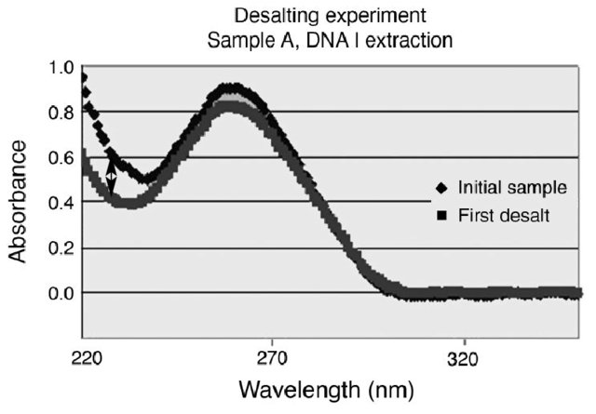
(From Boesenberg-Smith et al., 2012)

260/280 ratio and DNA concentration are in an acceptable range: according to QIAGEN (n.d.), pure DNA has a 260/280 ratio of 1.7-1.9 and DNA concentration of 1-50ng/μl, which can fulfil the amount of starting DNA for a 25µL PCR reaction. As reported from The Jackson Laboratory (2019), a 25µL PCR reaction typically requires ~5ng of pure DNA or 40-50ng of lower-quality DNA. To improve the purity of DNA, lengthening the ethanol drying time and increasing the number of washing times of AW1/AW2 buffer can be considered as methods to do so.
The low DNA purity can be the reason for the blundered original data, however, while it is true that there was significant contamination of the DNA extracted, the sample gel electrophoresis result showed clear bands, which indicates that the PCR was successfully conducted. A possible explanation for this is the inhibitor tolerance of the PCR mastermix. According to Hedman et al. (2011), different sources of DNA polymerase can make it differ in its tolerance therefore, an appropriate DNA polymerase-buffer system reduces PCR inhibition, which can be an alternative to DNA purification. As the PCR was successful, it can be inferred that the original data was unreadable due to failed gel electrophoresis. The reasons can be overloaded samples, physical agitation during running. To review the errors and improve the results, the experiment can be conducted in duplicates while applying the methods to enhance the purity of DNA.
The band around 300bp at Lane 5 (clinical isolate) of the sample data suggests the presence of the mecA gene, as the band was present in the MRSA sample but not in the MSSA sample. Therefore, it can be concluded that the clinical isolate is a MRSA strain.
Another gene that can be targeted is the mecC gene, a homolog of mecA and is found in 3% of MRSA strains. (Khan et al., 2020) It requires different primer pairs for PCR and commercial slide agglutination assays for mecA-encoded PBP2a can also not detect the mecC gene due to its nucleic acid sequence divergences. (Paterson et al., 2014) As there was a visible mecA gene in the results, alternative primers for the mecA gene were designed. To conduct a successful PCR, using adequate primers for the targeted sequence is crucial.

Figure 5
Primer Pair Designed for the MecA Gene

Typically, the primers must have similar melting temperatures (Tm): temperatures should not differ more than 2°C to allow both primers to bind at the same time. (Prediger, 2024) It is also required to have balanced G/C content with low self-complementarity. (Ye et al., 2012) Figure 5 shows the forward primer, 5’-TCAGGTTACGACAAGGTGA-3’, and reverse primer 5’-TGGCAGACAAATTGGGTGGT-3’. This primer pair anneal to the region of the mecA gene (Fig. 6) and ultimately defines the amplicon size.

Figure 6
Location of the Binding Section of the mecA Gene and Primer Pair
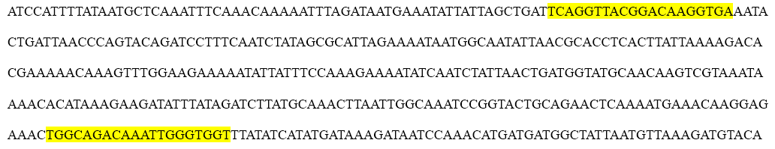

Using this primer pair, it is expected that the size of the amplicon will be around 300nm, which was achieved in the experiment. In the case of targeting the mecC gene, the band will show up at 137bp. (Salam and Saleh, 2020)
Quantitative PCR, also known as real-time PCR, requires less starting concentration of DNA, and no necessity to conduct gel electrophoresis as it measures fluorescence to measure DNA concentration. (Gautam and Kumar, 2020) Studies from Ho et al. (2009) and Kwon et al. (2012) confirm that qPCR can be successfully employed to amplify the mecA gene. To target both mecA and mecC genes, multiplex-PCR can be used. Multiplex PCR enables the amplification of two or more DNAs with a single reaction (Deharvengt and Tsongalis, 2018), and multiple experiments proved that it is possible to detect both mecA and mecC genes using multiplex-PCR. (Geha et al., 1994; Becker et al., 2013)

Conclusion
The primary goal of this experiment is to extract DNA from the clinical isolate and other control samples, amplify the targeted mecA gene via PCR, and confirm the presence of the gene from gel electrophoresis. Although the purity of extracted DNA was extremely low due to the possible contamination from guanidine salt and ethanol, the analysis of the sample result of the gel electrophoresis confirms that the mecA gene was present in the clinical isolate, as it showed a clear band around 300bp, identical to MRSA. The original result, on the other hand, did not show any bands other than the DNA ladder, which the contamination can be the reason. To overcome the inaccuracy of the result in future works, qPCR, which has higher sensitivity and tolerance, can be utilised, or the mecC gene can also be targeted using multiplex-PCR.

1,512 words
Summary of AI Use
Tool | How is it used in this assignment
Grammarly | To check spelling, grammar, or punctuation errors
Google Gemini 2.5 | To refine academic tone and language clarity

References
Becker, K., Larsen, A. R., Skov, R. L., Paterson, G. K., Holmes, M. A., Sabat, A. J., Friedrich,
A. W., Köck, R., Peters, G., & Kriegeskorte, A. (2013). Evaluation of a Modular Multiplex-PCR Methicillin-Resistant Staphylococcus aureus Detection Assay Adapted formecCDetection. Journal of Clinical Microbiology, 51(6), 1917–1919. https://doi.org/10.1128/jcm.00075-13
Boesenberg-Smith, K. A., Pessarakli, M. M., & Wolk, D. M. (2012). Assessment of DNA Yield
and Purity: an Overlooked Detail of PCR Troubleshooting. Clinical Microbiology Newsletter, 34(1), 1–6. https://doi.org/10.1016/j.clinmicnews.2011.12.002
Coventry University (2025). 5007BIO Laboratory Schedules 2,3 DNA extraction and PCR. &
PCR part 2 and some other fun Coventry University.
Deharvengt, S. J., & Tsongalis, G. J. (2018). Molecular pathology : the molecular basis of
human disease (pp. 709–730). Academic Press, An Imprint Of Elsevier.
Fishovitz, J., Hermoso, J. A., Chang, M., & Mobashery, S. (2014). Penicillin-binding Protein
2a of Methicillin-resistant Staphylococcus aureus. IUBMB Life, 66(8), 572–577. https://doi.org/10.1002/iub.1289
Geha, D. J., Uhl, J. R., Gustaferro, C. A., & Persing, D. H. (1994). Multiplex PCR for
identification of methicillin-resistant staphylococci in the clinical laboratory. Journal of Clinical Microbiology, 32(7), 1768–1772. https://doi.org/10.1128/jcm.32.7.1768-1772.1994
Hedman, J., Dufva, C., Norén, L., Ansell, C., Albinsson, L., & Ansell, R. (2011). Applying a
PCR inhibitor tolerant DNA polymerase blend in forensic DNA profiling. Forensic Science International: Genetics Supplement Series, 3(1), e349–e350. https://doi.org/10.1016/j.fsigss.2011.09.037
Ho, Y.-C., Chang, S.-C., Lin, S.-R., & Wang, W.-K. (2009). High Levels of mecA DNA
Detected by a Quantitative Real-Time PCR Assay Are Associated with Mortality in Patients with Methicillin-Resistant Staphylococcus aureus Bacteremia. Journal of Clinical Microbiology, 47(5), 1443–1451. https://doi.org/10.1128/jcm.01197-08
Khan, A. A., Ali, A., Tharmalingam, N., Mylonakis, E., & Zahra, R. (2020). First report of
mecC gene in clinical methicillin resistant S. aureus (MRSA) from tertiary care hospital Islamabad, Pakistan. Journal of Infection and Public Health, 13(10), 1501–1507. https://doi.org/10.1016/j.jiph.2020.05.017
Koetsier, G., & Cantor, E. (2019). A Practical Guide to Analyzing Nucleic Acid Concentration
and Purity with Microvolume Spectrophotometers. https://www.neb.com/- /media/nebus/files/application-notes/technote_mvs_analysis_of_nucleic_acid_concentration_and_purity.pdf?rev=c24cea043416420d84fb6bf7b554dbbb
Kumar, S., & Kumar, A. (2020). Natural remedies for pest, disease and weed control (pp.
135–142). London, United Kingdom] Academic Press.
Kwon, S.-J., Jeon, T., Seo, D., Na, M., Choi, E.-G., Son, J.-W., Yoo, E.-H., Park, C.-G., Lee,
H. Y., Kim, J. O., Kim, S.-Y., & Kang, J. (2012). Quantitative PCR for Etiologic Diagnosis of Methicillin-ResistantStaphylococcus aureusPneumonia in Intensive Care Unit. Tuberculosis and Respiratory Diseases, 72(3), 293. https://doi.org/10.4046/trd.2012.72.3.293
Malachowa, N., & DeLeo, F. R. (2010). Mobile genetic elements of Staphylococcus aureus.
Cellular and Molecular Life Sciences, 67(18), 3057–3071. https:// doi.org/10.1007/s00018-010-0389-4
Paterson, G. K., Harrison, E. M., & Holmes, M. A. (2014). The emergence of mecC
methicillin-resistant Staphylococcus aureus. Trends in Microbiology, 22(1), 42–47. https://doi.org/10.1016/j.tim.2013.11.003
Prediger, E. (2024). Rules and Tips for PCR & qPCR Primer Design | IDT. IDT.
https://eu.idtdna.com/page/support-and-education/decoded-plus/how-to-design-primers-and-probes-for-pcr-and-qpcr/
QIAGEN. (n.d.). Quantification of DNA. Qiagen.com. Retrieved November 23, 2025, from
https://www.qiagen.com/gb/knowledge-and-support/knowledge-hub/bench-guide/dna/analysing-dna/quantification-of-dna#Spectrophotometry
QIAGEN. (2021). Buffer AW1 Safety Data Sheet (SDS) cover letter for product: Buffer AW1.
Rao, A., Fader, B., & Hocker, K. (2010). Molecular diagnostics : techniques and applications
for the clinical laboratory (pp. 327–340). Elsevier/Academic Press.
Salam, S. A., & Saleh, A. N. (2020). Prevalence of MecC Gene Among Methicillin
Resistant Staphylococcus aureus isolated from Patients in Ain-Shams University
Hospital. ResearchGate. https://www.researchgate.net/publication/356392032_Prevalence_of_MecC_Gene_Among_Methicillin_Resistant_Staphylococcus_aureus_isolated_from_Patients_in_Ain-Shams_University_Hospital
Shahkarami, F., Rashki, A., & Rashki Ghalehnoo, Z. (2014). Microbial Susceptibility and
Plasmid Profiles of Methicillin-Resistant Staphylococcus aureus and Methicillin-Susceptible S. aureus. Jundishapur Journal of Microbiology, 7(7). https://doi.org/10.5812/jjm.16984
Siddiqui, A., & Koirala, J. (2023). Methicillin resistant Staphylococcus aureus
(MRSA). National Library of Medicine; StatPearls Publishing. https://www.ncbi.nlm.nih.gov/books/NBK482221/
Taylor, T. A., & Unakal, C. G. (2023). Staphylococcus aureus infection. National Library of
Medicine; StatPearls Publishing. https://www.ncbi.nlm.nih.gov/books/NBK441868/
The Jackson Laboratory. (2019). PCR Tips. The Jackson Laboratory. https://www.jax.org/jax-
mice-and-services/customer-support/technical-support/genotyping-resources/general-pcr-reminders-dos-and-donts
UK. Health Security Agency. (2024). Quarterly epidemiological commentary:
mandatory Gram-negative
bacteraemia, MRSA, MSSA and C. difficile infections (data up to October to December 2024). GOV.UK. https://www.gov.uk/government/statistics/mrsa-mssa-gram-negative-bacteraemia-and-cdi-quarterly-report/quarterly-epidemiological-commentary-mandatory-gram-negative-bacteraemia-mrsa-mssa-and-c-difficile-infections-data-up-to-october-to-december-2024
UK Health Security Agency. (2023). Annual epidemiological commentary: Gram-negative,
MRSA, MSSA bacteraemia and C. difficile infections, up to and including financial year 2022 to 2023. GOV.UK. https://www.gov.uk/government/statistics/mrsa-mssa-and-e-coli-bacteraemia-and-c-difficile-infection-annual-epidemiological-commentary/annual-epidemiological-commentary-gram-negative-mrsa-mssa-bacteraemia-and-c-difficile-infections-up-to-and-including-financial-year-2022-to-2023
Ye, J., Coulouris, G., Zaretskaya, I., Cutcutache, I., Rozen, S., & Madden, T. L. (2012).
Primer-BLAST: A tool to design target-specific primers for polymerase chain reaction. BMC Bioinformatics, 13(1). https://doi.org/10.1186/1471-2105-13-134

Appendix
Table 1
Prevalence of healthcare-associated MRSA (HA-MRSA) and community-acquired MRSA (CA-MRSA) in Different Countries
Year of study | Prevalence | Sample size | Sample sources | Country | References
Hospital-acquired MRSA (HA-MRSA)
2004 | 25.0% | 758 | Human patients | United States | Davis et al., 2004
2009 | 46.0% | 6743 | Humans | India | Arora et al., 2010
2013 | 58.4% | 1487 | Humans | Portugal | Tavares et al., 2013
2016 | 4.6% | 726 | Health care workers | Germany | Sassmannshausen et al., 2016
2008–2016 | 38.9% | 318 | Nose, ear, blood, pus, wounds, abscesses, eyes, genital | Norway | Enger et al., 2022
2015–2017 | 45.0% (658/1466) | 1466 | Hospital patients | China | Chen et al., 2022
2017 | 52% | 180 | Human blood | Pakistan | Siddiqui et al., 2017
2011–2019 | 35.1% | 210 | Inpatients and outpatients | Japan | Hosaka et al., 2022
2018–2019 | 21.0% | 164 | Blood and soft tissues | Japan | Ogura et al., 2022
2019 | 50% | 742 | children | Uganda | Kateete et al., 2019
2014–2020 | 23.4% | 565 | Blood, pus, wound exudate, sputum | China | Wang et al., 2022
2019–2020 | 55.7% | 97 | Wound, pus, CSF, blood, skin lesions, sputum, joint fluid, ear, nose, throat | Iran | Tabandeh et al., 2022
2020 | 43.44% | 200 | Wound, nose, cerebrospinal fluid of patients | Pakistan | ur Rehman et al., 2020
2020 | 15.1% | 456 | Blood | Australia | Coombs et al., 2022
2017–2021 | 26.0% | 76 | Ear, rectal swabs, oropharyngeal, nose, skin, wound, conjunctiva, bone, urine, synovial and peritoneal fluid, lymph node | Italy | La Vecchia et al., 2022
2021 | 19.1% | 47 | Nose, pharynx, and mobile phone | Mexico | Hamdan-Partida et al., 2022
2021 | 34.8% | 295 | Urine, sputum, wound swabs, nasal swabs, fomites | Nigeria | Ugwu et al., 2022
Community-acquired MRSA (CA-MRSA)
2005 | 7.3% | 726 | Anterior nares culture | United States | Hidron et al., 2005
2005 | 12.82% | 14253 | Nasal and inguinal swabs | Switzerland | Harbarth et al., 2005
2009 | 38.5% | 120 | Dialysis patients | United Kingdom | Johnson et al., 2009
2012 | 64.7% | 178 | Pus sample | India | Alvarez-Uria and Reddy, 2012
2008–2016 | 61.0% | 318 | Nose, ear, blood, pus, wounds, abscesses, eyes, genital | Norway | Enger et al., 2022
2015–2017 | 24.0% (105/434) | 434 | Community settings | China | Chen et al., 2022
2017 | 1.7% | 753 | Nasal sample | China | Bi et al., 2018
2017 | 2.8% | 404 | Pig ear swab | China | Bi et al., 2018
2018 | 23.5% | 152 | Nasal swabs | Pacific Asia | Wong et al., 2018
2018–2019 | 79.0% | 164 | Blood and soft tissues | Japan | Ogura et al., 2022
2019–2020 | 16.0% | 25 | Nasal swabs | Egypt | Mostafa et al., 2022
2019–2020 | 44.3% | 97 | Wound, pus, CSF, blood, skin lesions, sputum, joint fluid, ear, nose, throat | Iran | Tabandeh et al., 2022
2020 | 84.9% | 456 | Blood | Australia | Coombs et al., 2022
2021 | 28.7% | 295 | Urine, sputum, wound swabs, nasal swabs, fomites | Nigeria | Ugwu et al., 2022
(From Shoaib et al., 2023)
Note. This table was reordered from the original data chronologically to facilitate understanding of long-term trends. Original data can be accessed via: https://pmc.ncbi.nlm.nih.gov/articles/PMC9871788/

Figure 1
The Original Gel Electrophoresis Data
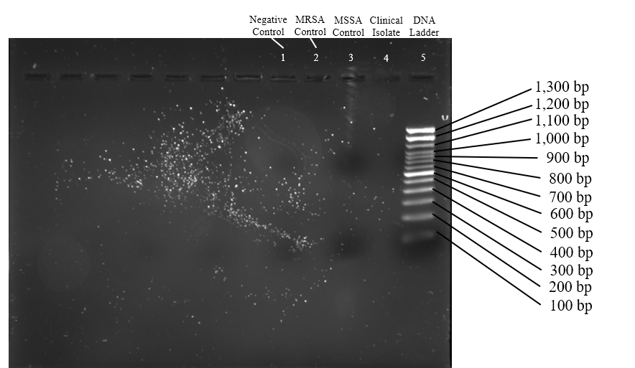

Figure 2
Full Sequence and Primer Binding Spot of the mecA Gene
